1)Scenario is client want to see application files , so we can sync the container with local system to avoid client access container by use following command

2)we want one ec2 ubyntu server so we go to launch then login to putty

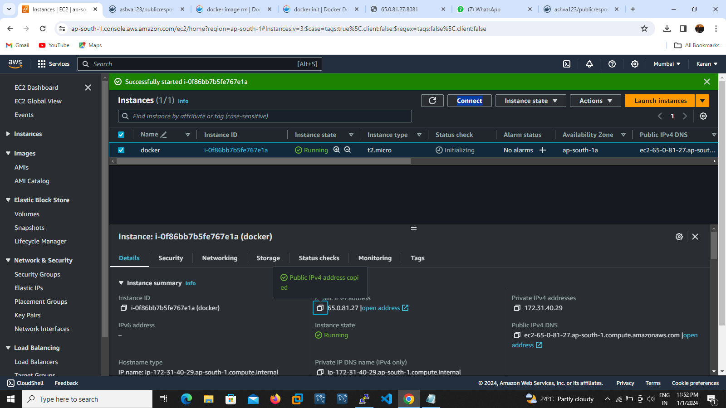

3) After install docker application using ubuntu packaging commands apt-get install docker.io –y .

4) apt-get update to update your environment

5)create one directory in root directory then we will go launch container with volumes sync command

6) docker run -itd --name developeraccess -p "8010:80" -v "/root/developer:/usr/local/apache2/htdocs" httpd

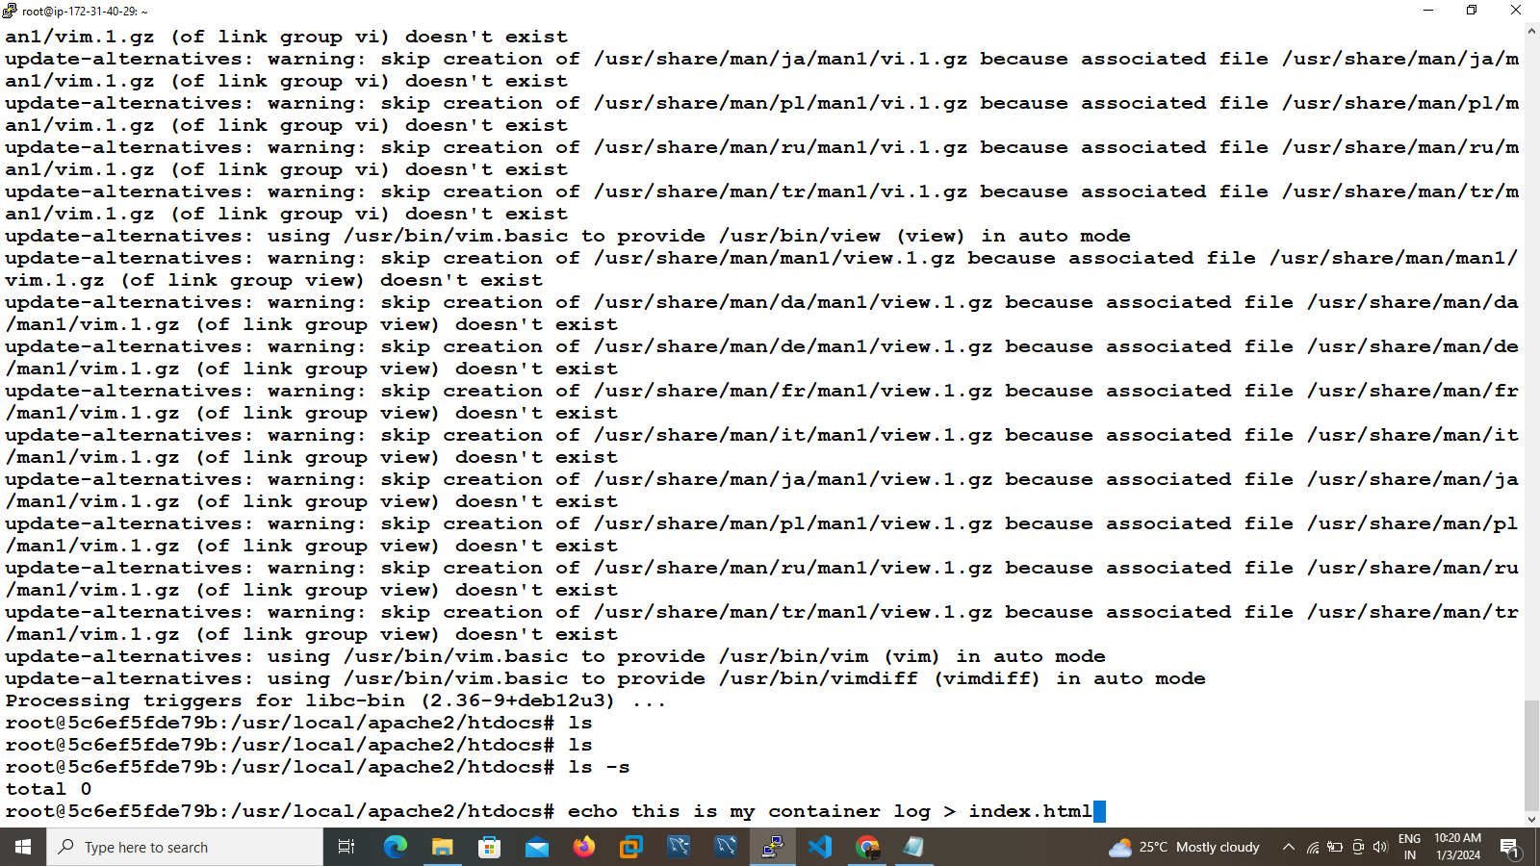

7)here the container successfully launced ensure by using following command docker ps

8)nxt navigate to our container docker exec <container id> /bin/bash

9)here check in htdocs directory default index.html file not available

10)so update our environment and install vim

apt-get update

apt-get install vim

11)create one file with content follow by the command

Echo this is my container > index.html

12)once ensure using cat command

13)successfully created index file its replication is done in local server .

14)go to your local server then check the while created directory there index file also available.

